Ideation Phase
Empathize & Discover

Date | 27 June 2025
Team ID | LTVIP2025TMID36160
Project Name | Citizen AI – Intelligent Citizen  Engagement Platform
Maximum Marks | 4 Marks

Empathy Map Canvas:
An empathy map is a simple, easy-to-digest visual that captures knowledge about a user’s behaviours and attitudes.

It is a useful tool to help teams better understand their users.
Creating an effective solution requires understanding the true problem and the person who is experiencing it. The exercise of creating the map helps participants consider things from the user’s perspective, along with his or her goals and challenges.
Example:
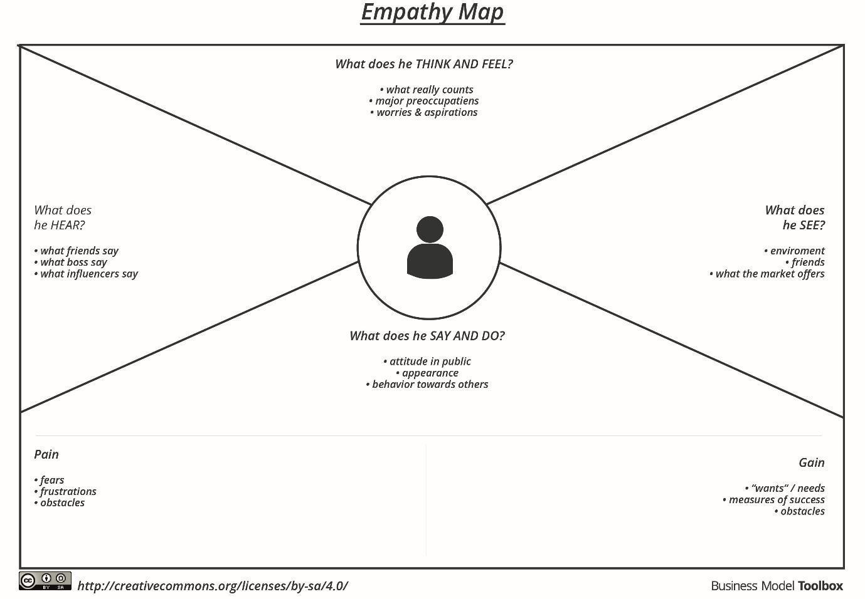

Example: Citizen AI – Intelligent Citizen Engagement Platform
